Types of Subject Complement
# Source: AI Source: Provided by: [Data Path: Persons Table -> ID Column: 1, Name_En Column: Motasem Essam] -> From: [ChatGPT] on [8/4/2025]
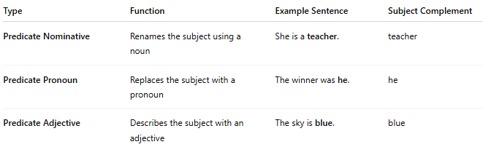

Type | Function | Example Sentence | Subject Complement
Predicate Nominative | Renames the subject using a noun | She is a teacher. | teacher
Predicate Pronoun | Replaces the subject with a pronoun | The winner was he. | he
Predicate Adjective | Describes the subject with an adjective | The sky is blue. | blue

